|  |  |  |  |  |  |
| --- | --- | --- | --- | --- | --- |
| Date | 30-Nov-22 | | | Tester Name | Mayuri Patel |
| Environment | Penfax - Test | | | Login used |  |
| Operating System | Select OS | Version: | Update: | | |
| Software Used | Select Software | Version: | Update: | | |
| Select Software | Version: | Update: | | |
| Release version | 22.4.1 | | | | |
| Title |  | | | | |
| Test Type | Regression | | | | |
| Test Scenario | Change Tax instructions | | | | |
|  |  | | | | |
| Expected Results |  | | | | |
| Pass/Fail | Pass | | | JIRA# | N/A |

Describe your steps with screenshots:

Search for a member to change the Tax Instruction

Open that member Profile

Under Person Profile go to Tax Instruction

Add new Tax Instruction

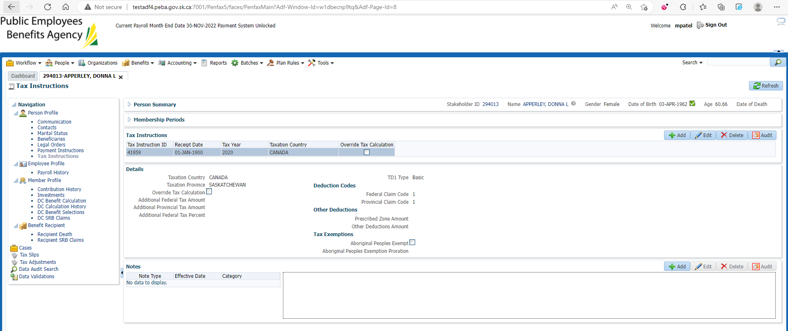

Enter mandatory details and Save

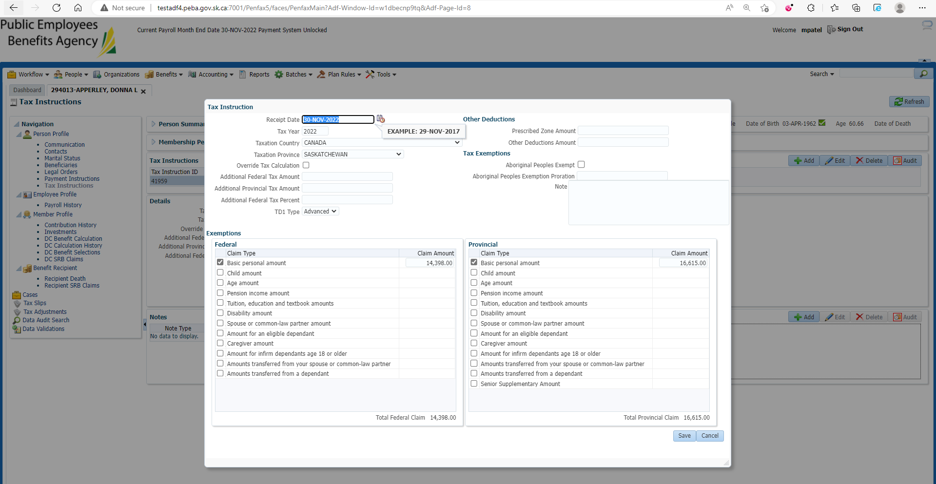

New Tax Instruction is added

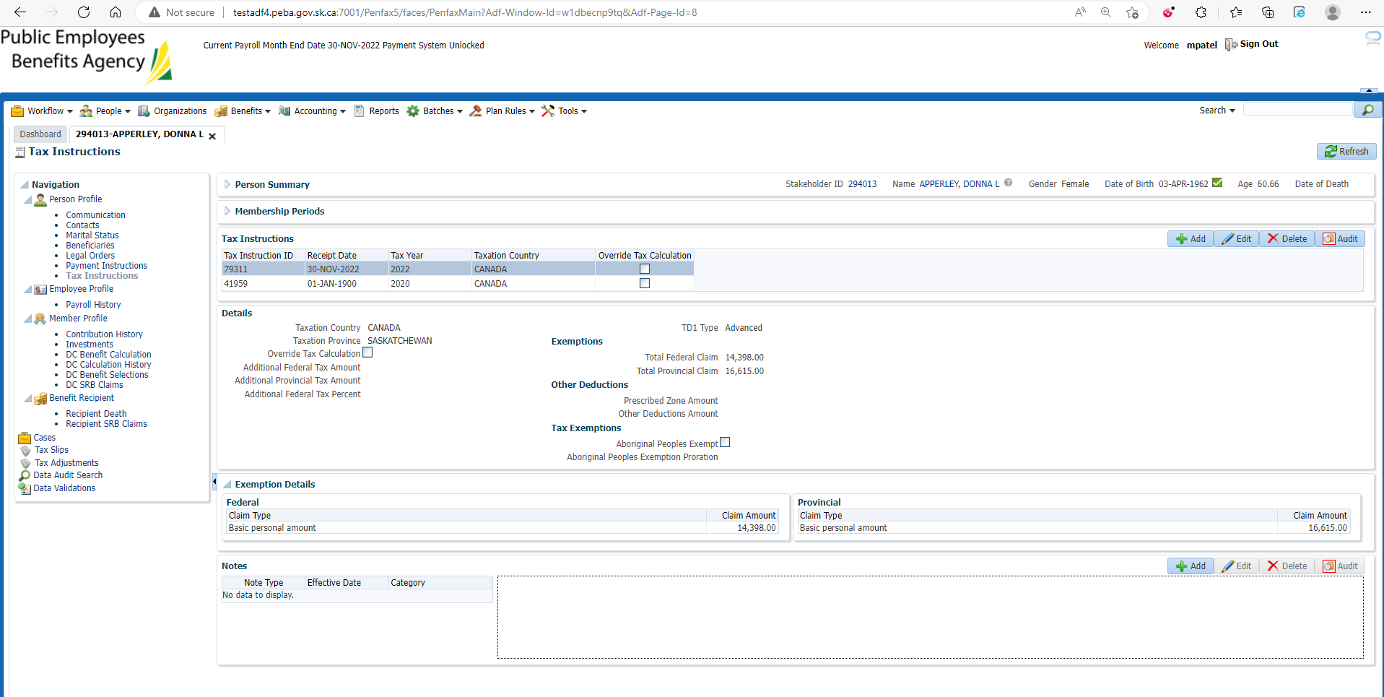

Go to Benefit Recipient

Under Income Benefit tab🡪Tax instruction

Edit the old Tax Instruction by entering the end date

Add new Tax Instruction that is created in previous step

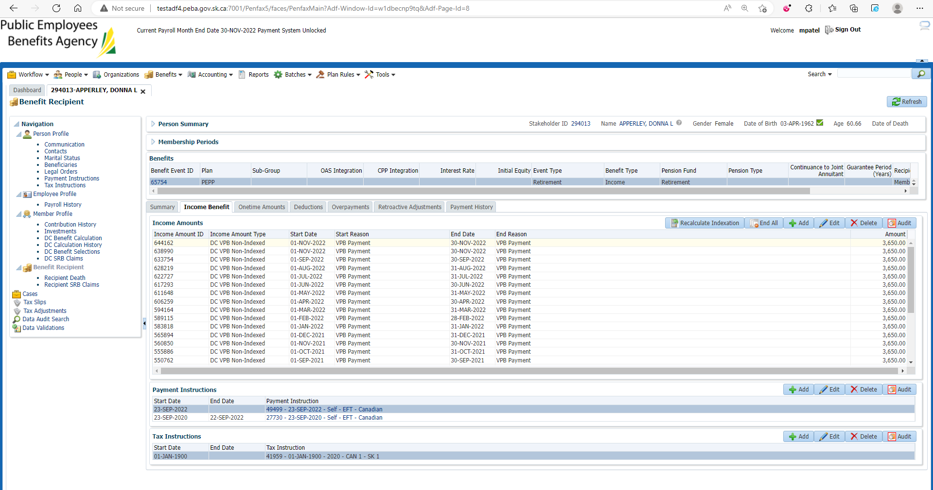

Changes are reflected

